Assignment – 3
1. Flask API Route
app.py :
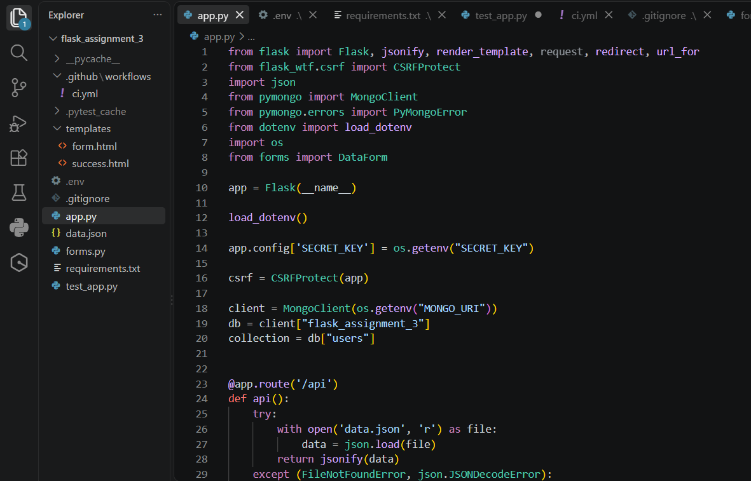
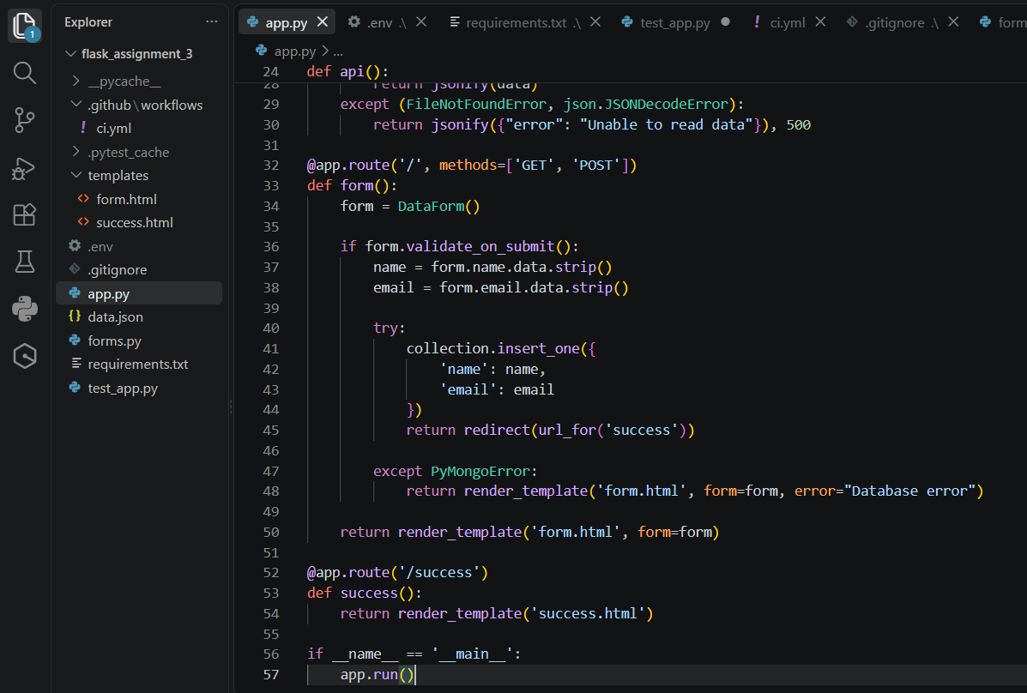
Explanation: The Flask application contains an /api route that is used to provide data in JSON format. When the /api route is accessed, the application opens the data.json file and reads the stored data. The data is then converted into JSON format and returned as the response. This allows the frontend or any client to access the data through the Flask API.

data.json :
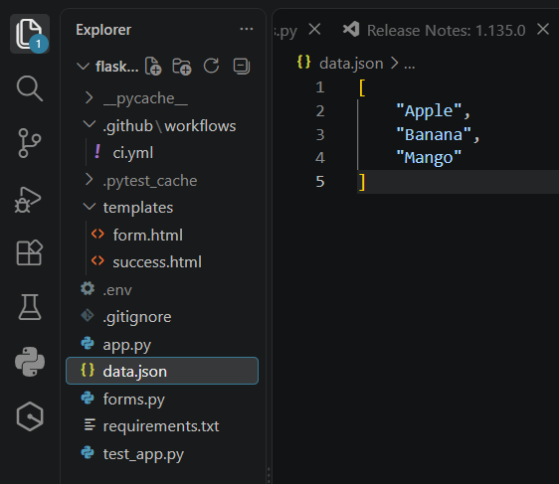
Explanation: The data.json file is used as the backend data file for the Flask application. It contains the data in JSON format. The /api route reads this file and sends its data as a JSON response when the API is accessed.
/api JSON response :
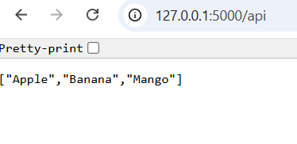
Explanation: The /api route reads the data from the data.json file and returns it as a JSON response in the browser.

2. Frontend Form
form.html :
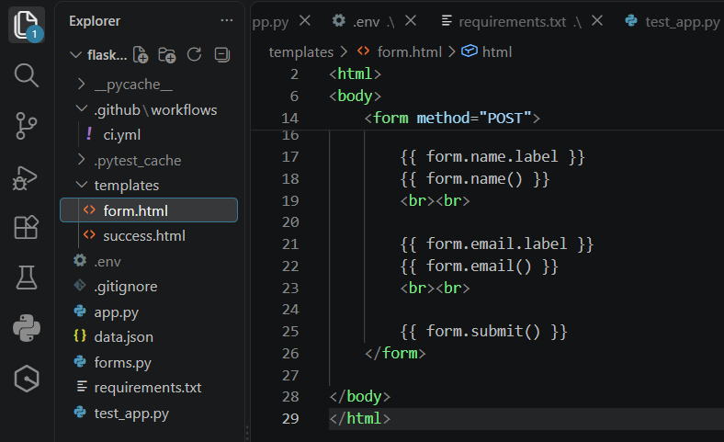
Explanation: The form.html file provides the frontend form through which users can enter and submit their data to the Flask application.
forms.py :
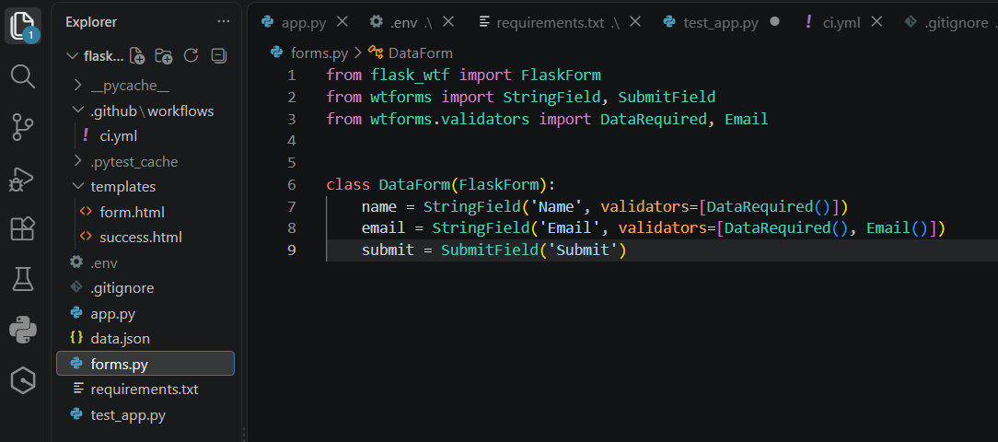
Explanation: The forms.py file defines the form fields used to collect user input. It is used by the Flask application to handle and validate the submitted form data.

3. MongoDB Submission
Successful Submission :
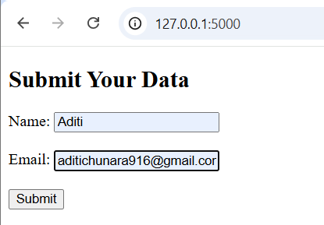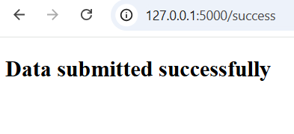
Explanation: The submitted form data is successfully stored in MongoDB, and the application displays a success message after the submission is completed.

success.html :
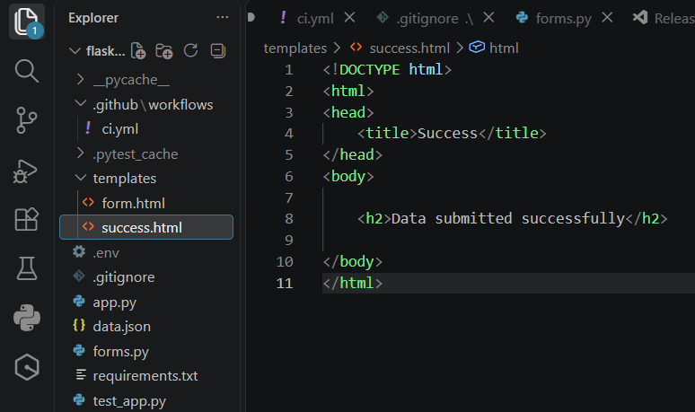
Explanation: The success.html file displays a confirmation message to the user after the form data has been successfully submitted.

4. Testing
test_app.py :
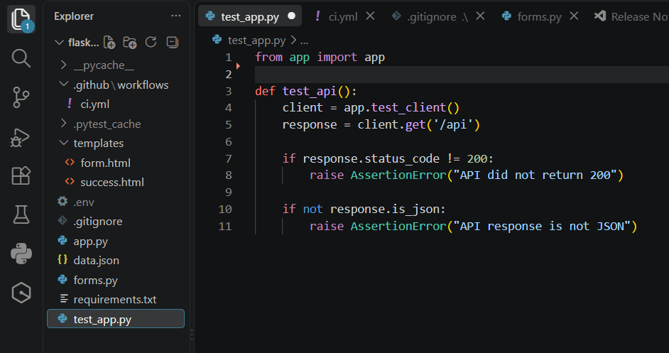
Explanation: The test_app.py file contains tests for the Flask application to check whether the application and its API route work correctly.
Pytest Result :
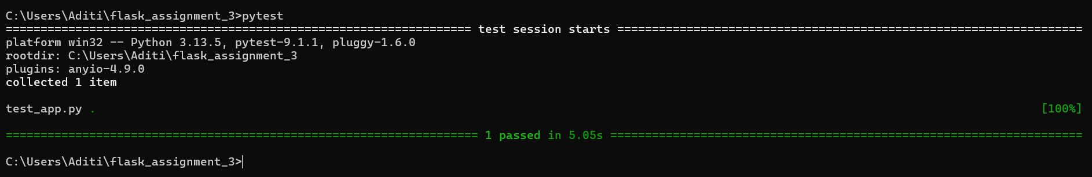
Explanation: The pytest result shows that the application test was executed successfully and 1 test passed without any errors.

5. Security Scan
Bandit scan :
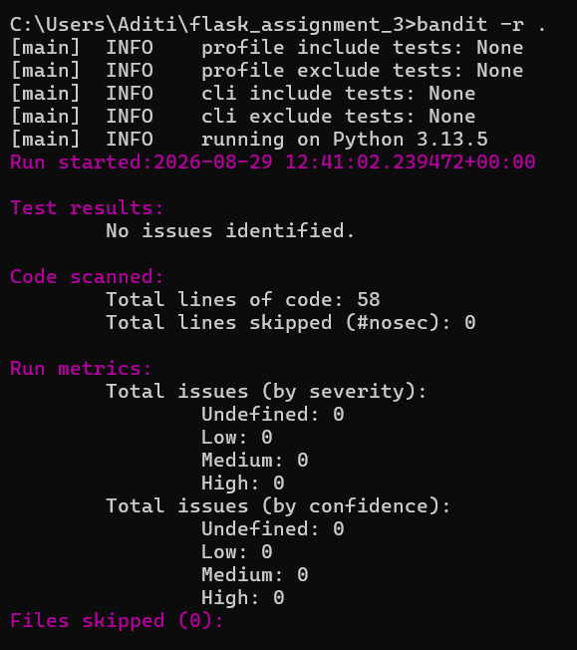
Explanation: Bandit was used to scan the Python code for common security issues. The scan completed successfully without identifying any security issues.

6. CI/CD
.github/workflows/ci.yml :
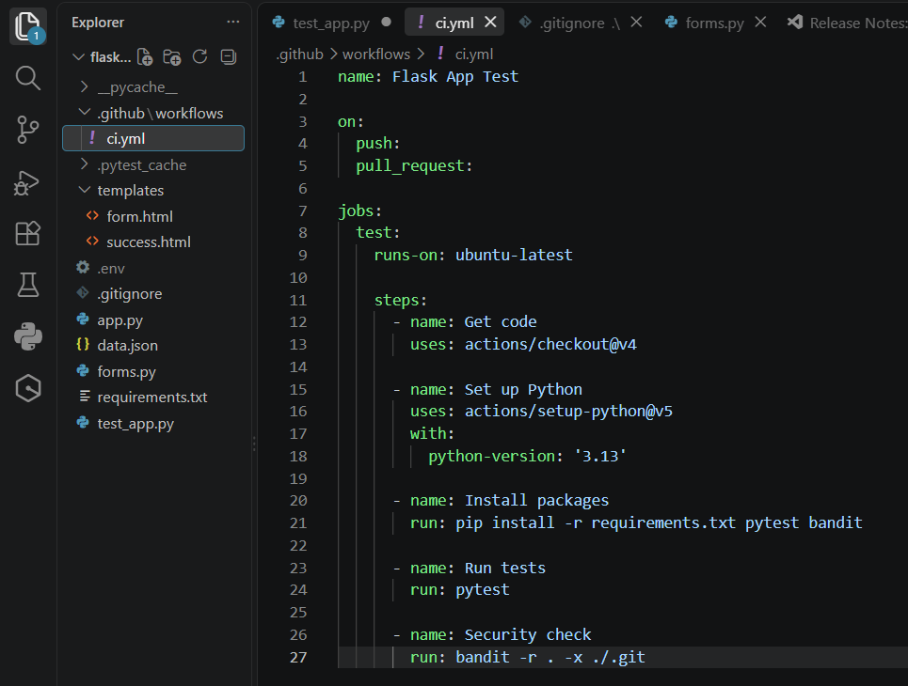
Explanation: The ci.yml file defines the GitHub Actions workflow used to automatically run the project checks whenever changes are pushed to the repository.
GitHub Actions :
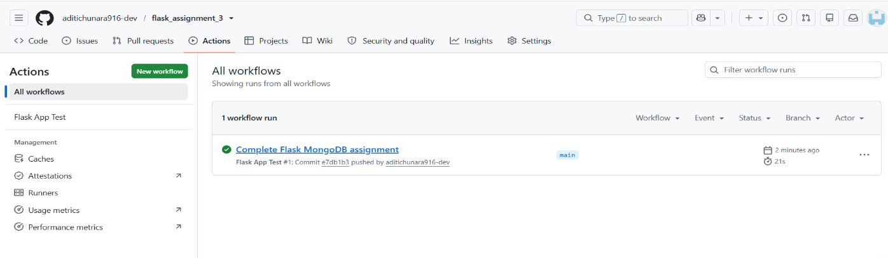
Explanation: The GitHub Actions workflow completed successfully, shown by the green check mark. This confirms that the automated CI checks passed successfully.

7. GitHub Repository
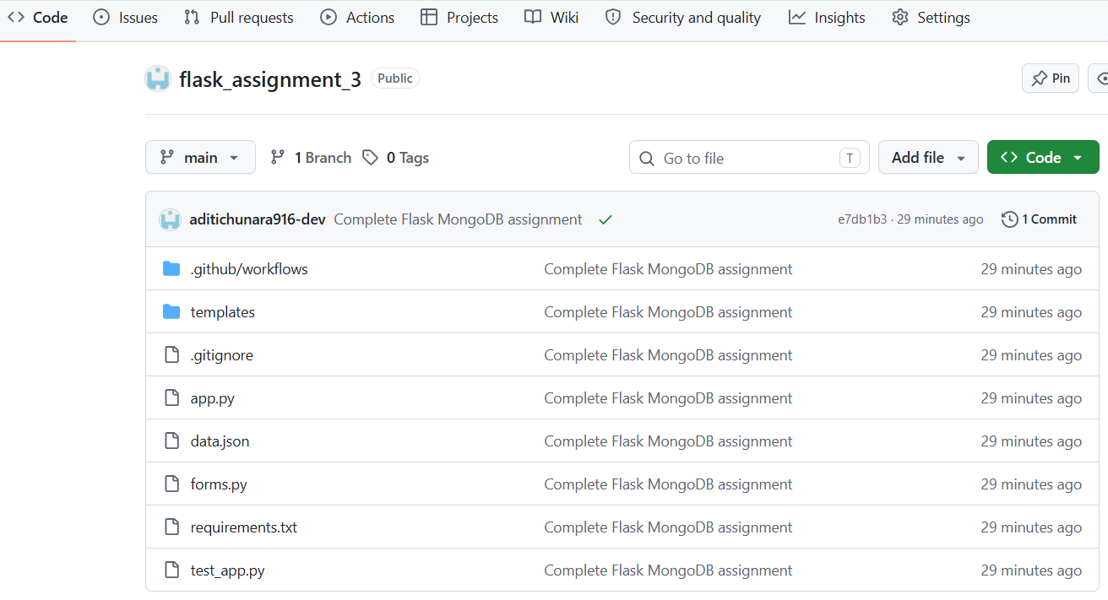
Explanation: The GitHub repository contains the Flask application source code, frontend templates, data file, tests, requirements, and CI/CD workflow.

GitHub repository link :
https://github.com/aditichunara916-dev/flask_assignment_3

